DATE: 07.09.2018
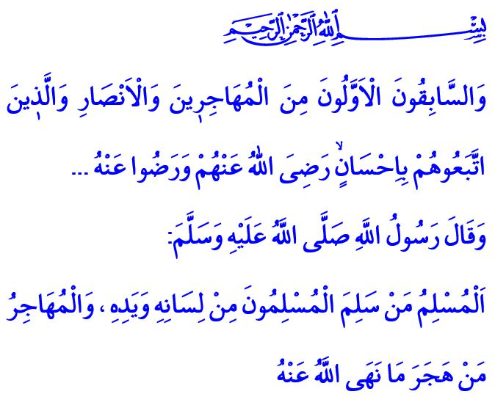
THE HIJRAH
Jumu’ah Mubarak Beloved Brothers and Sisters!
With the grace and beneficence of Allah the Almighty (swt), we will attain the first day of the month of Muharram next Tuesday, and we will start the 1440th year after the Hijrah. I pray to our Almighty Lord (swt) that this beginning, which is the anniversary of the the Hijrah, bring goodness to our nation and the Islamic world.
Esteemed Believers!
The polytheists, who did not accept the prophethood of our Prophet, the Pride of the Universe (saw), did all kinds of persecution, repression and torture to him and the believers. When it became impossible for them to live in Mecca, Allah the Exalted (swt) permitted them to migrate to a peaceful city, i.e. Madinah, where they would be able to live their religion freely and perform their worships easily. A group of the believers had departed first, and then our Prophet (saw) with His faithful friend Abu Bakr (ra) migrated to Madinah.
Honorable Muslims!
This noble journey of the Islamic history is not an ordinary migration only, but a symbol of search for opportunity for the right and the truth to dominate the earth. Hijrah is the indicator of belief in Allah, loyalty, submission, patience, and perseverance to Him (swt). Hijrah is the meeting of the devout Muhajirun (immigrants), who gave up everything they possessed for the countenance of Allah and for the serenity and peace of humankind, with the generous Ansar (helpers) who received them with open arms.
In the Holy Qur’an, the Muhajirun and the Ansar, who became brothers through this troublesome and blessed journey, are heralded as follows: “And the first forerunners [in the faith] among the Muhajirun and the Ansar and those who followed them with good conduct - Allah is pleased with them and they are pleased with Him…”
Dear Brothers and Sisters!
The Hijrah is not an incident that took place and came to an end in the Asr al-Saadah (the Age of Bliss). Today, too, many Muslims have to leave their homes and homelands in tears and hit the roads, seeking asylum with people who would become Ansar for them as the representatives of the goodness. What falls upon us in this regard is that we endeavor to stand against and stop oppression and injustice, remembering again this fact on the anniversary of the Hijrah.
Hijrah also means leaving behind any kind of badness, staying away from evil, and taking steps towards goodness and benevolence. The spiritual aspect of Hijrah is, in fact, expressed with the following words of our beloved Prophet (saw): “ A Muslim is the one from whose tongue and hands the Muslims are safe; and a Muhajir is the one who refrains from what Allah has forbidden.”
Esteemed Believers!
In the essence of Hijrah lie sincerity and good intention. Devotion to Allah (swt) and affection for the Prophet (saw) make up the yeast of it. Believers become Muhajir when they hold on to life with faith and hope despite the sorrowful days they have experienced. The Muhajir comprehend the meaning of Hijrah when they turn their back on haram and meticulously follow halal.
Honorable Muslims!
As the new Hijri year is around the corner, we as Muslims should better hold ourselves to account for the year we are leaving behind soon, and shape our future plans accordingly. Our Hijrah should be from disobedience to obedience, sin to repentance, arrogance to humility, discord to unity, enmity to brotherhood, ignorance to knowledge, and from evil to good.
Come! In this blessed hour of the Jumu’ah prayer while remembering the Hijrah, let us become Ansar for our Muhajir brothers and sisters who had to leave their homes and homelands in an effort to escape from the oppression of the oppressors. Let us once again set our intention to flourish the journey of our life with perfect faith, good deeds, and good morality. Let us direct our route, road, and Hijrah towards Allah (swt) and the Prophet (saw).

Tawbah, 9/100.
Bukhari, Iman, 4. General Directorate of Religious Services

